Request for Annual Standing Order
(Instructions to your bank or building society)
Please pay to Barclays Bank Sort Code 20-72-37
Friends of Fordingbridge Museum
Account number 10949523

The sum of £……………………….

Amount in words………………………………………………………….
on receipt and annually on the 1st January until further notice.
From (name of your bank or building society):

…………………………………………………………………………………….

Address………………………………………………………………………..

……………………………………………………………..……………………..

Sort Code:……………..A/C No:…………………………………………

A/C name……………………………………………………………………..

Signature(s)………………………………………………………………….

Date …………………………………………………………………………….

We will keep your details secure and only contact you about your membership, to inform you of events and to send newsletters. Your bank details will not be retained after the standing order has been set up.
OPPORTUNITIES TO HELP
If you wish to take an active part in helping the museum, there are plenty of opportunities to become more involved by offering your time with tasks around the museum or taking part in any of our fund raising or awareness events. Please fill in the box on the back of the membership form.

Fordingbridge Museum
King’s Yard Salisbury Street, Fordingbridge,
Hampshire, SP6 1AB
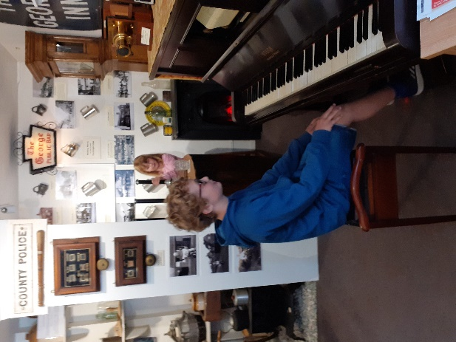
Email : - info@fordingbridgemuseum.co.uk
Visit our website at: -www.fordingbridgemuseum.co.uk
Find us on Facebook at: -https://www.facebook.com/Fordingbridge.museum
Please give details of any areas where you have interest or expertise and would be willing to help: -

“Hands on” (decorating and DIY jobs, cleaning, mounting displays, etc.)

Fund raising events and activities

Museum jobs (steward, shop, cataloguing, photographic and artefacts team)

Other skills (please give details on a separate sheet)
(Registered Charity No. 1072427)
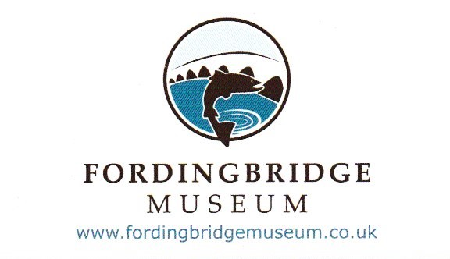
Friends of Fordingbridge Museum
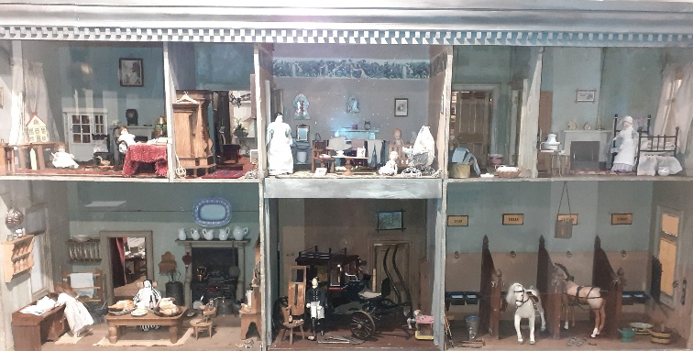

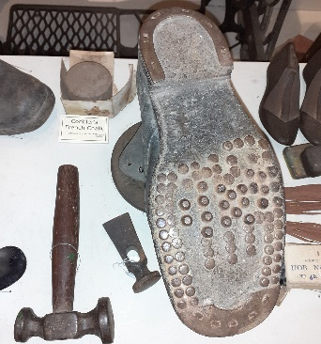

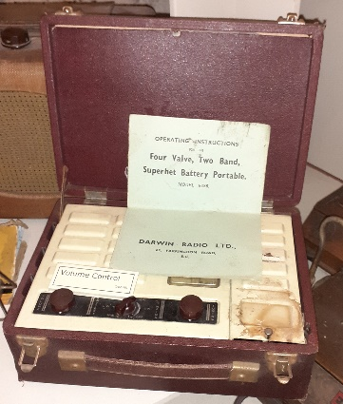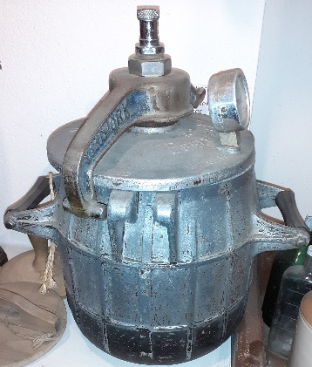

Where did we come from?

The story began in 1995 when the Shering Collection, which had been started more than 30 years before, was offered to the town of Fordingbridge.
The first problem was to find a home for the collection. The current building in Kings Yard was purchased by the County Council for the collection. The Museum is now entirely run by volunteers and receives no council funding.
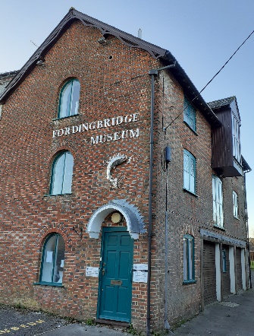

The Shering collection is mainly from the local area. It is a unique record of social and domestic life, spanning more than 200 years. It includes photographs and documents as well as artefacts, large and small from homes, farms and businesses. The collection forms the basis of the Museum, which has seen continual development over the years.

Not all the items can be displayed in the space available, many are in store. The displays are changed from time to time, to show some of the stored items and to make return visits more interesting.
The care of the artefacts, the displays, the stewarding of the museum, stalls at local fairs and fundraising events are all achieved by the generous giving of time and skills by the Museum Friends and other volunteers.
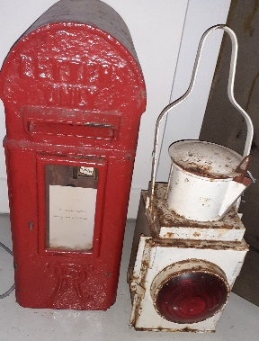

Why Be a Friend?

The main benefit of being a Friend of Fordingbridge Museum is a sense of belonging and supporting the Museum which has become a valuable feature of the town. It is run entirely by volunteers.

Our friendly organisation produces newsletters with articles of local interest and details of talks, our fundraising activities and social events.

The Friends are a valuable fundraising body. The Museum receives no council funding and relies on activities run by the Friends, grants, legacies and
donations
Some Friends like to get involved as volunteers in the Museum, helping with fundraising events, assisting with the archives, helping with “behind the scenes” activities, promoting the Museum by helping with outreach activities such as local school visits, stewarding, running the shop, creating displays, or working on the photographic and the artefacts teams.

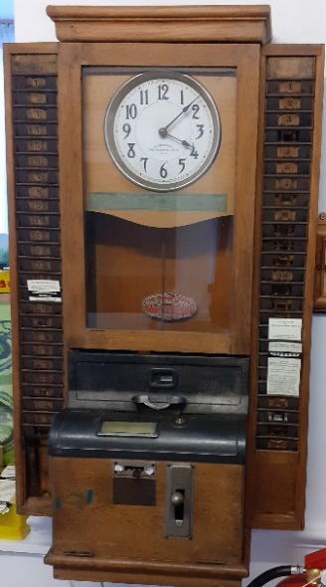

Want to Join?
If you would like to become a Friend please complete the form opposite, detach and send to the Membership Secretary, Fordingbridge Museum, Kings Yard, Salisbury Street, Fordingbridge, Hampshire, SP6 1AB

Application for Membership

Name ………………………………………………………………………..

Address ……………………………………………………………………..

…………………………………………………………………………………….

Post code …………………… Tel no ………………………………….

Email ……………………………………………………………………………

I am happy for the FoFM to contact me by: -

Email: Yes / No Post: Yes / No Phone: Yes / No

Please tick type of membership required: -

Annual Individual £10
Annual Family (up to 2 children) £15
Individual Life Membership £75
Family Life Membership £100
Annual Corporate minimum £25

For greatest convenience, please complete the Standing Order form overleaf.

If you would prefer to pay each year, or include a donation, please complete the section below: -

I enclose: -
Membership subscription £ ………
Donation £ ………
Cheque/Cash enclosed £ ………

Signature ………………………………………………………..

Date ………………………………………………………………..

If you pay tax, the Friends can reclaim tax already paid by you, under the Gift Aid Scheme. Please tick the box below, if you wish to do this, and a Gift Aid Declaration will be sent to you.

